EXPERIMENT 1: SUBJECT AVERAGE AND HIGHEST AVERAGE

AIM
To calculate the average marks in Math, Science, English, and History using NumPy and identify the subject with the highest average.

ALGORITHM
- Import the NumPy library.
- Create a 4 × 4 array containing marks of four students in four subjects.
- Calculate the average of each subject using np.mean() with axis=0.
- Find the index of the highest average using np.argmax().
- Display the average marks and the subject with the highest average.

PROGRAM / CODE
import numpy as np
student_scores = np.array([
[80, 75, 85, 70],
[90, 88, 80, 75],
[70, 82, 90, 80],
[85, 80, 75, 85]
])
subjects = ["Math", "Science", "English", "History"]
average = np.mean(student_scores, axis=0)
print("Average marks of each subject:")
for i in range(4):
print(subjects[i], ":", average[i])
highest = np.argmax(average)
print("Subject with highest average:", subjects[highest])

CODE:
import numpy as np

student_scores = np.array([
[80, 75, 85, 70],
[90, 88, 80, 75],
[70, 82, 90, 80],
[85, 80, 75, 85]
])

subjects = ["Math", "Science", "English", "History"]

average = np.mean(student_scores, axis=0)

print("Average marks of each subject:")
for i in range(4):
print(subjects[i], ":", average[i])

highest = np.argmax(average)
print("Subject with highest average:", subjects[highest])

INPUT
Student marks (4 × 4 matrix):
[[80, 75, 85, 70],
[90, 88, 80, 75],
[70, 82, 90, 80],
[85, 80, 75, 85]]

OUTPUT
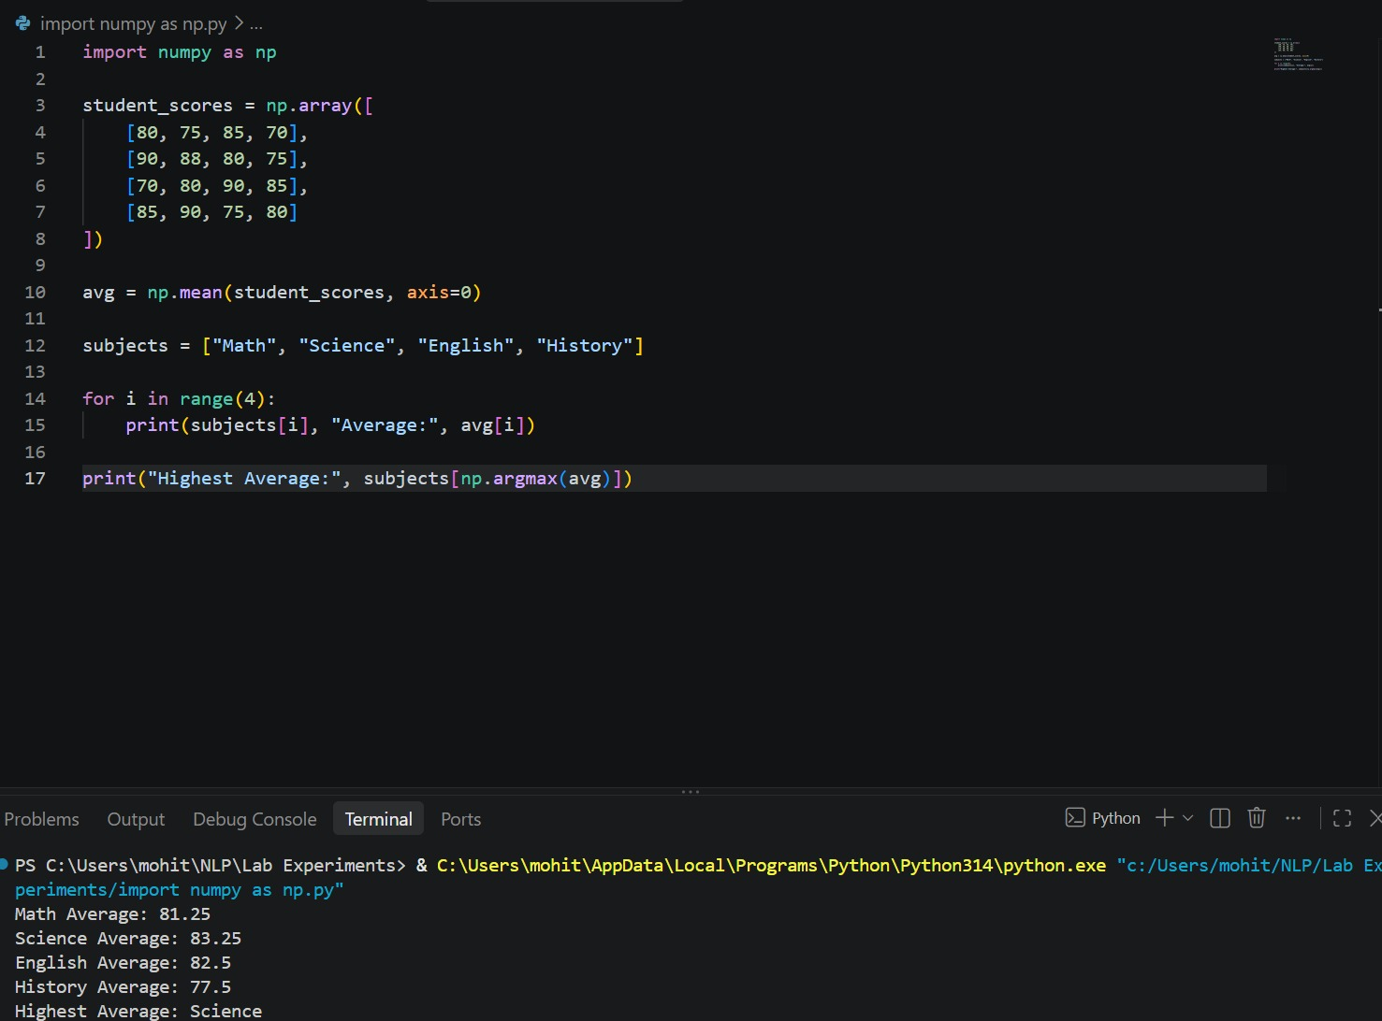
Average marks of each subject:
Math : 81.25
Science : 81.25
English : 82.5
History : 77.5
Subject with highest average: English

RESULT
The program calculates the average marks for all four subjects and identifies English as the subject with the highest average, 82.5.

